# IT 140 Design Document Template

## Instructions

Fill out the sections below. Be sure to remove the bracketed text before submitting your Design Document.

[Insert Your Name Here]

## Storyboard (Description and Map)

[Include a paragraph description of your theme, storyline, rooms, items, and villain here. Be sure to also complete the map below with *your* rooms and items. You may add more rooms and directions if you like. Use the **Insert** menu and select **Shapes** to add textboxes and arrows.]

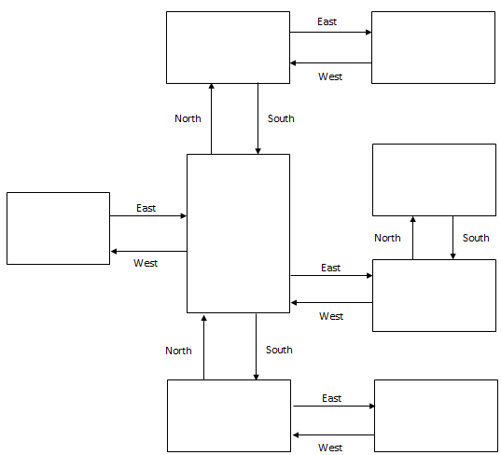

## Pseudocode or Flowchart for Code to “Move Between Rooms”

[Write pseudocode or create/insert your flowchart here.]

## Pseudocode or Flowchart for Code to “Get an Item”

[Write pseudocode or create/insert your flowchart here.]